|  |
| --- |
| Serial No: |
| **2nd Mid Term Exam**  **Spring Semester 2020** |
| **Max Time: 3 Hour** |
| **Max Marks: 60**  **Exam Weight (Out of 100). 10** |
|  |

|  |
| --- |
| **CS302-Design and Analysis of Algorithm** |
| Monday, June 2, 2020 |
| **Course Instructor** |
| Mr. Adeel Ashraf Cheema  Mr. Muhammad Haris  Mr. Shoaib Saleem |

|  |  |  |  |  |  |
| --- | --- | --- | --- | --- | --- |
| **Name:** | **Hassan Ashas** | **Roll No:** | **18F-0128** | **Section:** | **D** |

**General Instructions:**

1. There are Four (4) Questions in total.
2. Questions reading and understanding are also part of the exam, only answer what is asked.
3. Read the questions carefully for clarity of context and understanding of meaning and make assumptions wherever required, for neither the invigilator will address your queries, nor the teacher/examiner will respond to any of your queries.

**Guidelines for Submission:**

1. You must solve/attempt it on paper in your handwriting on paper and take the picture of that solution and insert it in provided docx file. The image can be pasted inside that document under the appropriate question.
2. You should submit only one PDF answer sheet file Containing All four questions Answers Images.
3. You can change the attached Docx file and add your questions answer images into it and submit it.
4. Naming Convention of file must be followed.
5. Example:
   1. Rollnumber_Section.pdf
   2. 18f0123_C.pdf
6. You must submit your answer sheet before due time in Assignment Section via

**Slate** [**http://203.124.42.218:8080/portal**](http://203.124.42.218:8080/portal)**.**

1. Submissions submitted after the due time shall not be considered.
2. If you don’t finish every part of a question, don’t worry! You can still submit what you’ve done to get marks based on your efforts.
3. **In case of copied or plagiarized solutions in exam Or If a student provided help to another student during exam both will be awarded "F" grade and it will affect the student CGPA.**
4. Viva of any student can be conducted by the instructor after conducting an online exam in case of any doubt.
5. The answer sheet should be submitted through **Slate** [**http://203.124.42.218:8080/portal**](http://203.124.42.218:8080/portal)**.**

**But in the worst case, you can email it to your class teacher within the deadline.**

**Guidelines for attempting:**

1. Your answer sheet (Every Image File) must contain your Full name, Roll number and Section and Cleary written in top of the page and must be in readable form.
2. Handwriting must be readable.
3. Proper explain the steps.
4. Answer without steps or explanation (Direct Calculated answer) will get ZERO marks.

|  |  |  |  |  |  |
| --- | --- | --- | --- | --- | --- |
|  | **Q-1** | **Q-2** | **Q-3** | **Q-4** | **Total** |
| **Total**  **Marks** | **20** | **5** | **15** | **20** | **60** |
| **Marks Obtained** |  |  |  |  |  |

**Question 1: Solution: Upload Image of your work here**

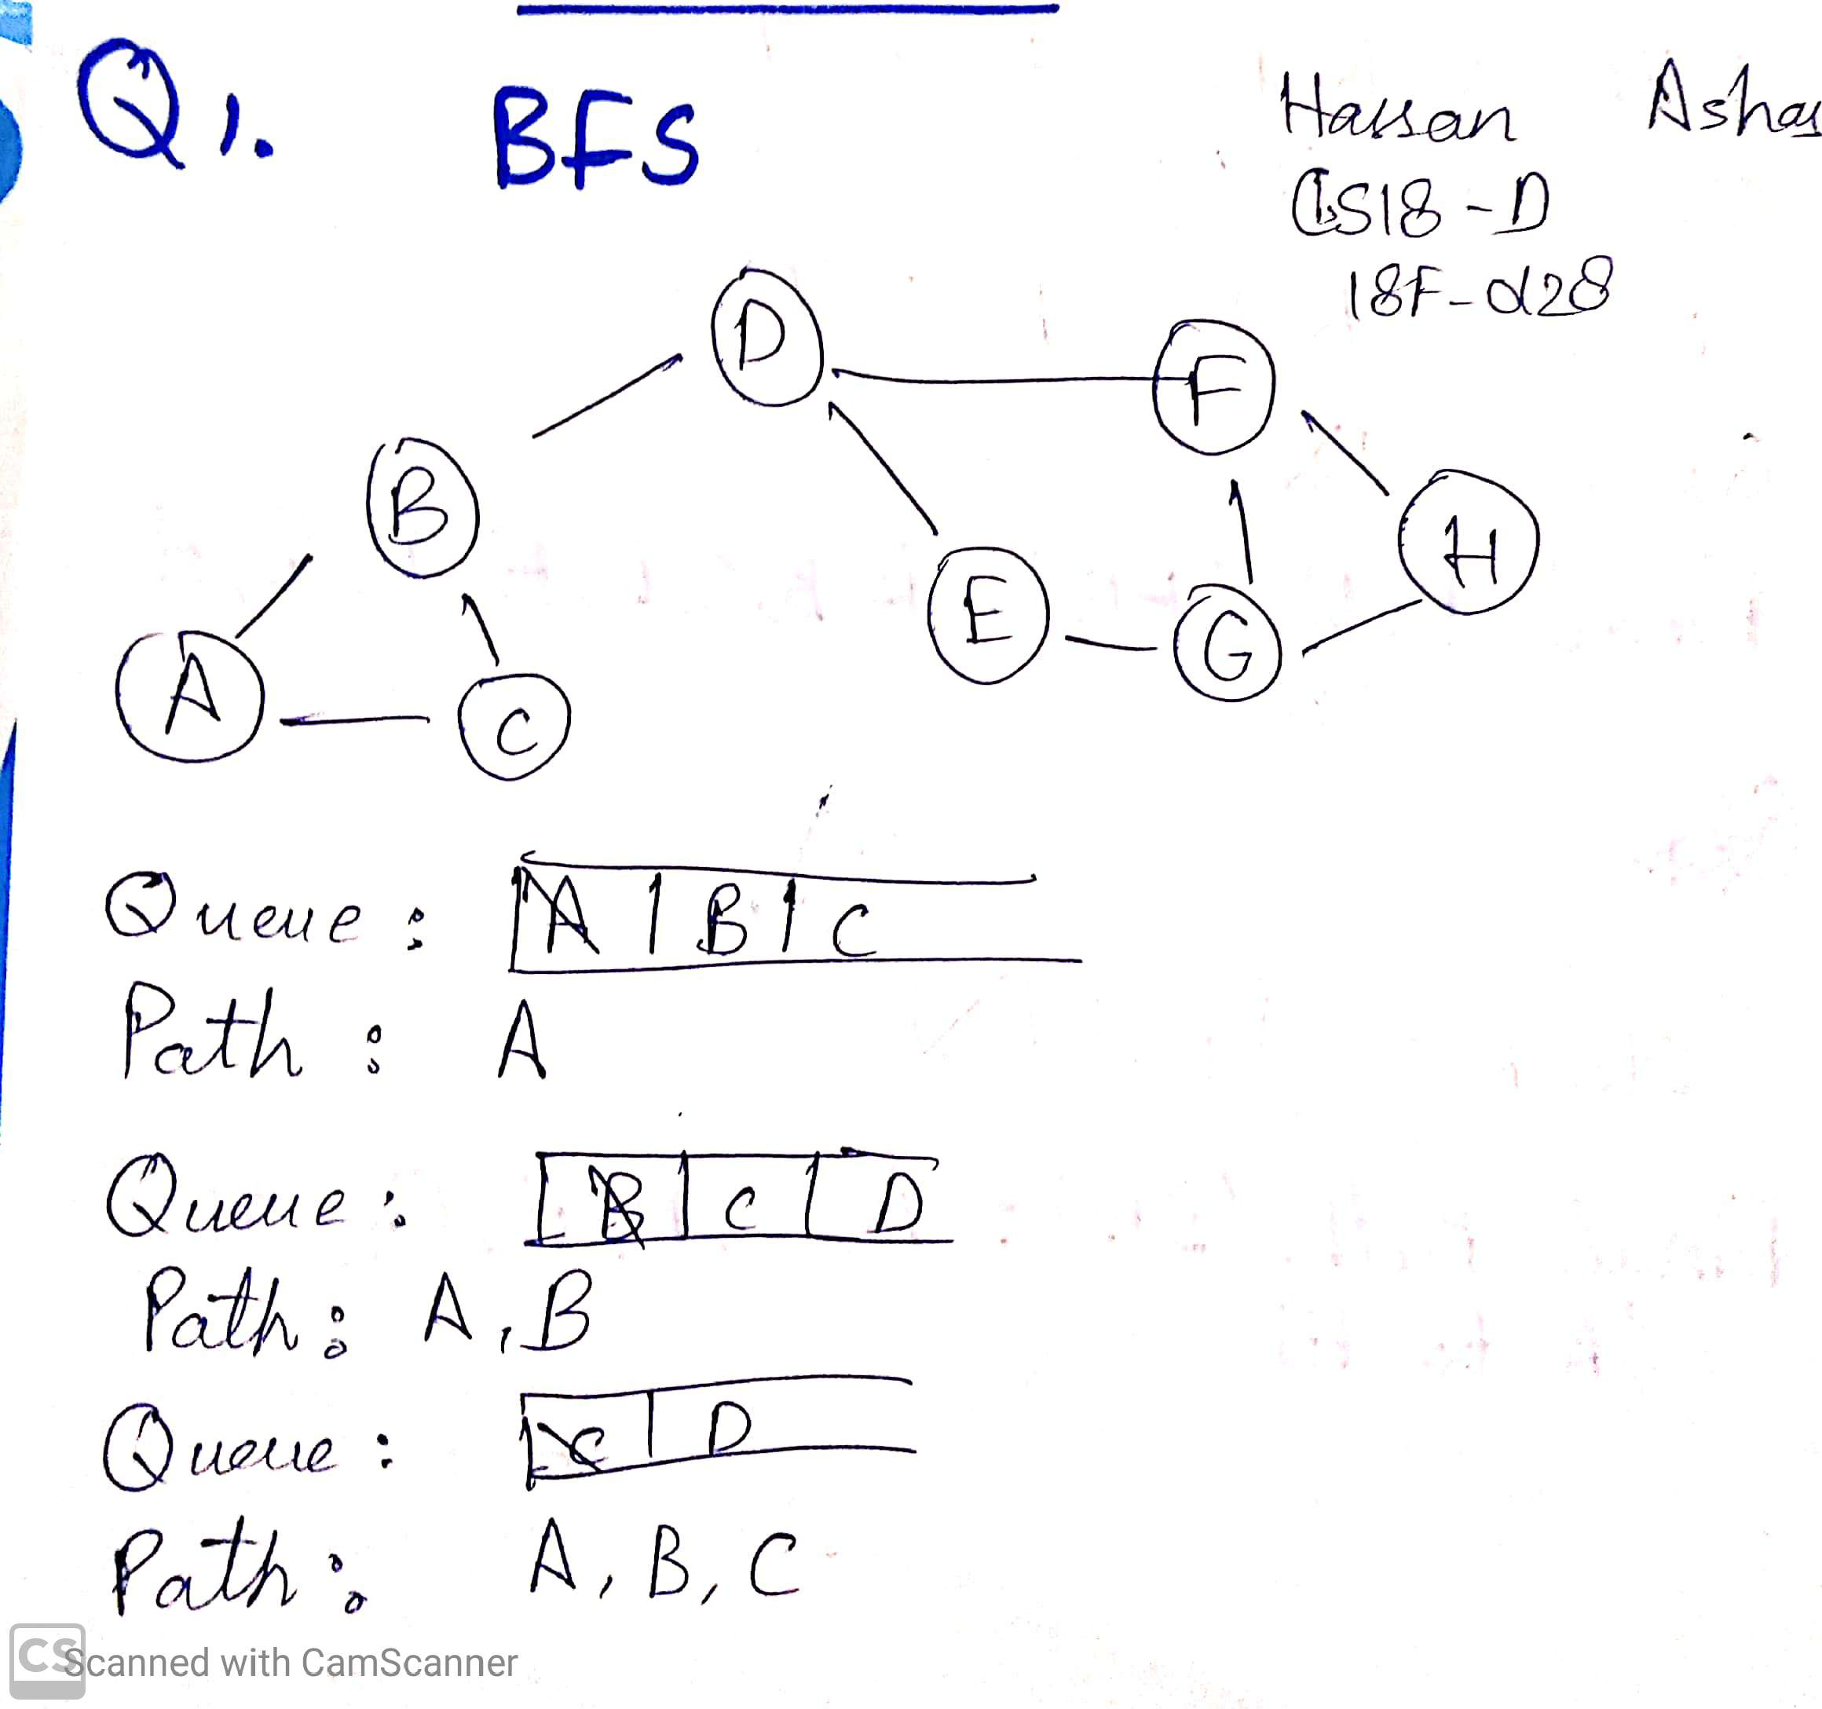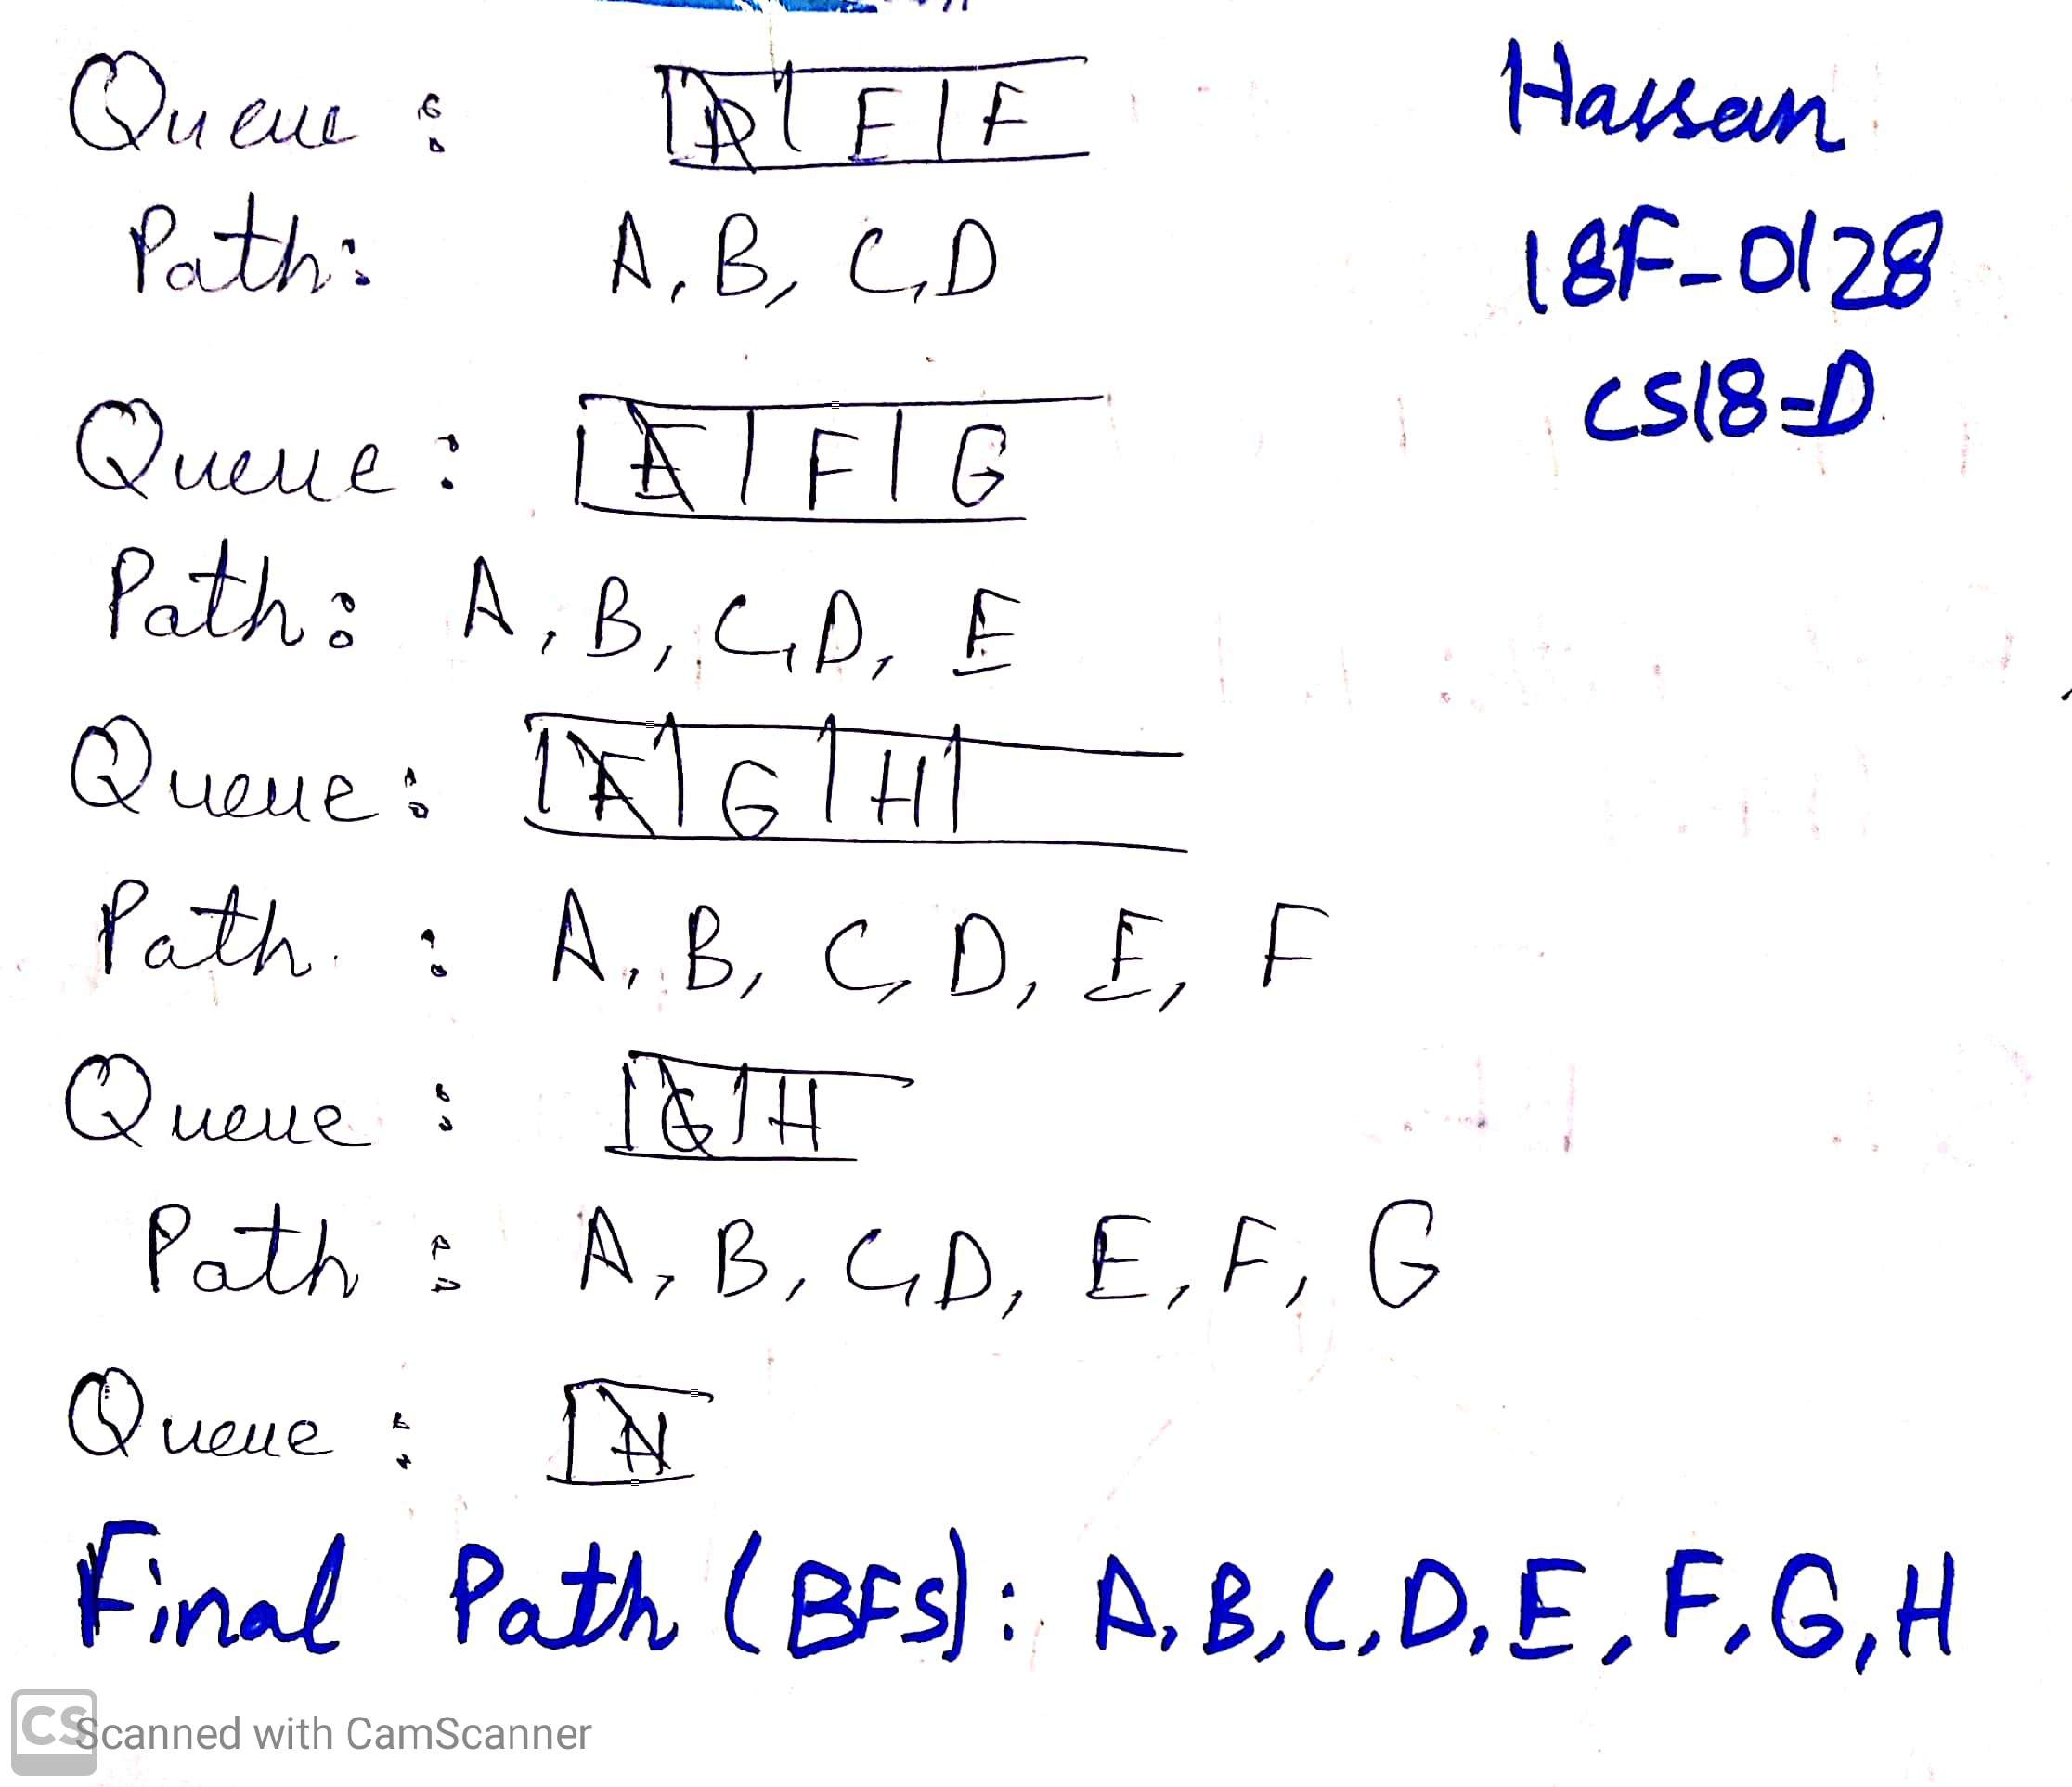

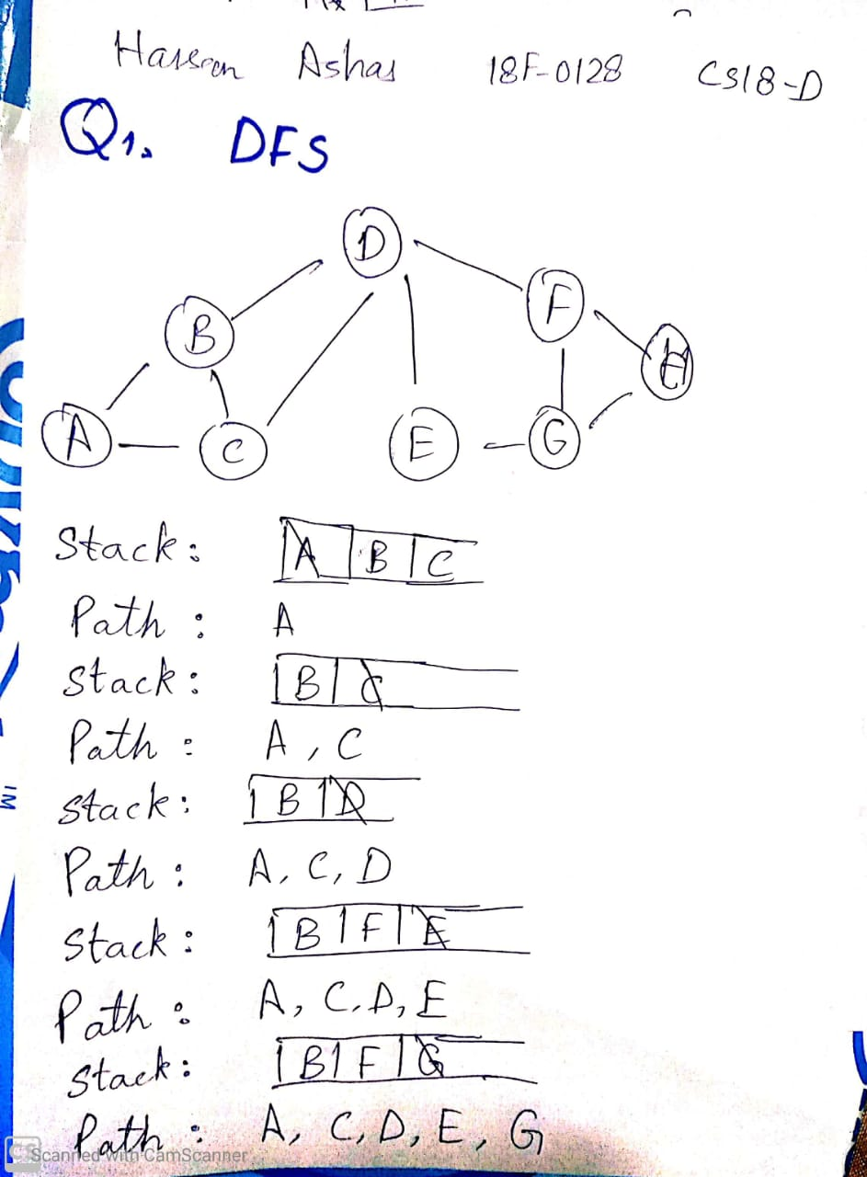

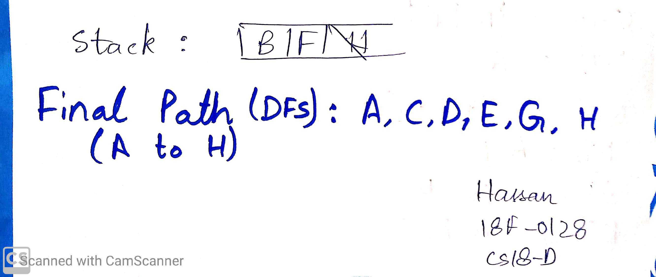

**Question 2: Solution: Upload Image of your work here**

Didn’t Attempt.

**Question 3: Solution: Upload Image of your work here**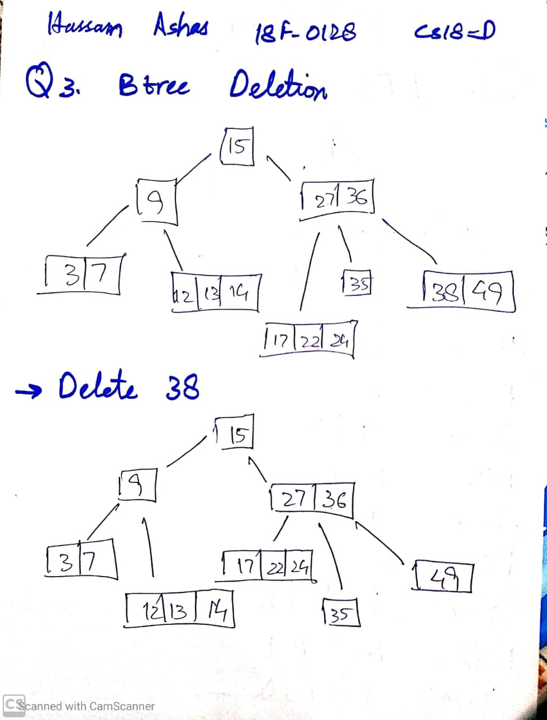

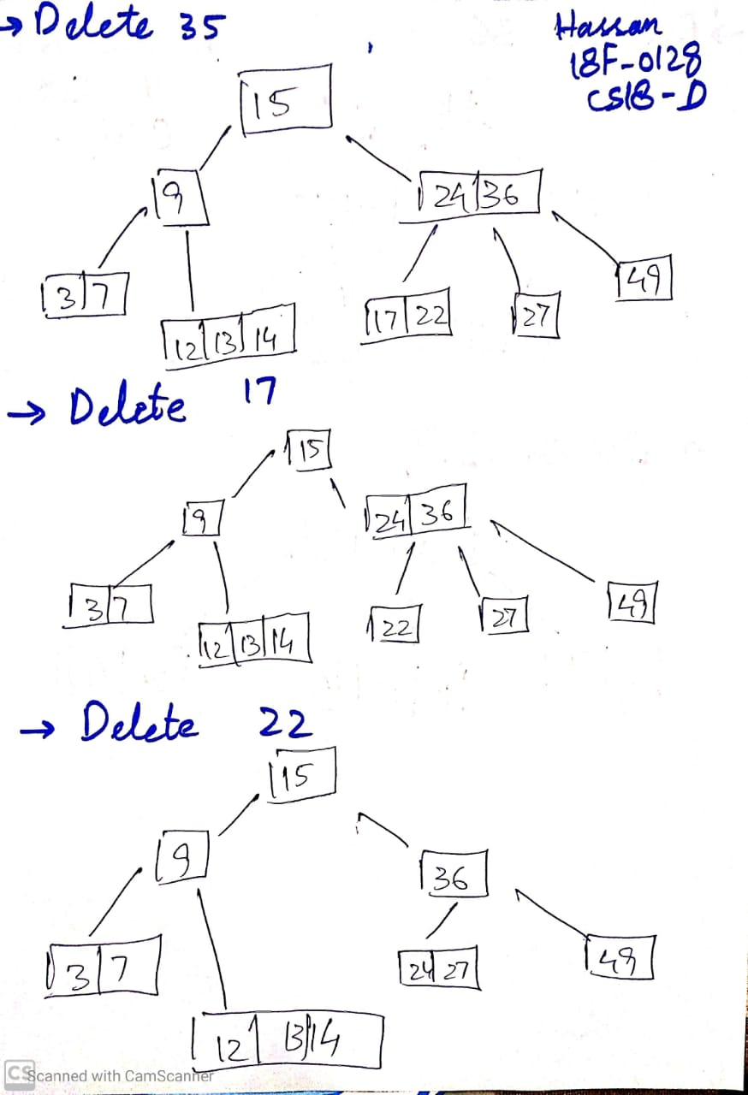

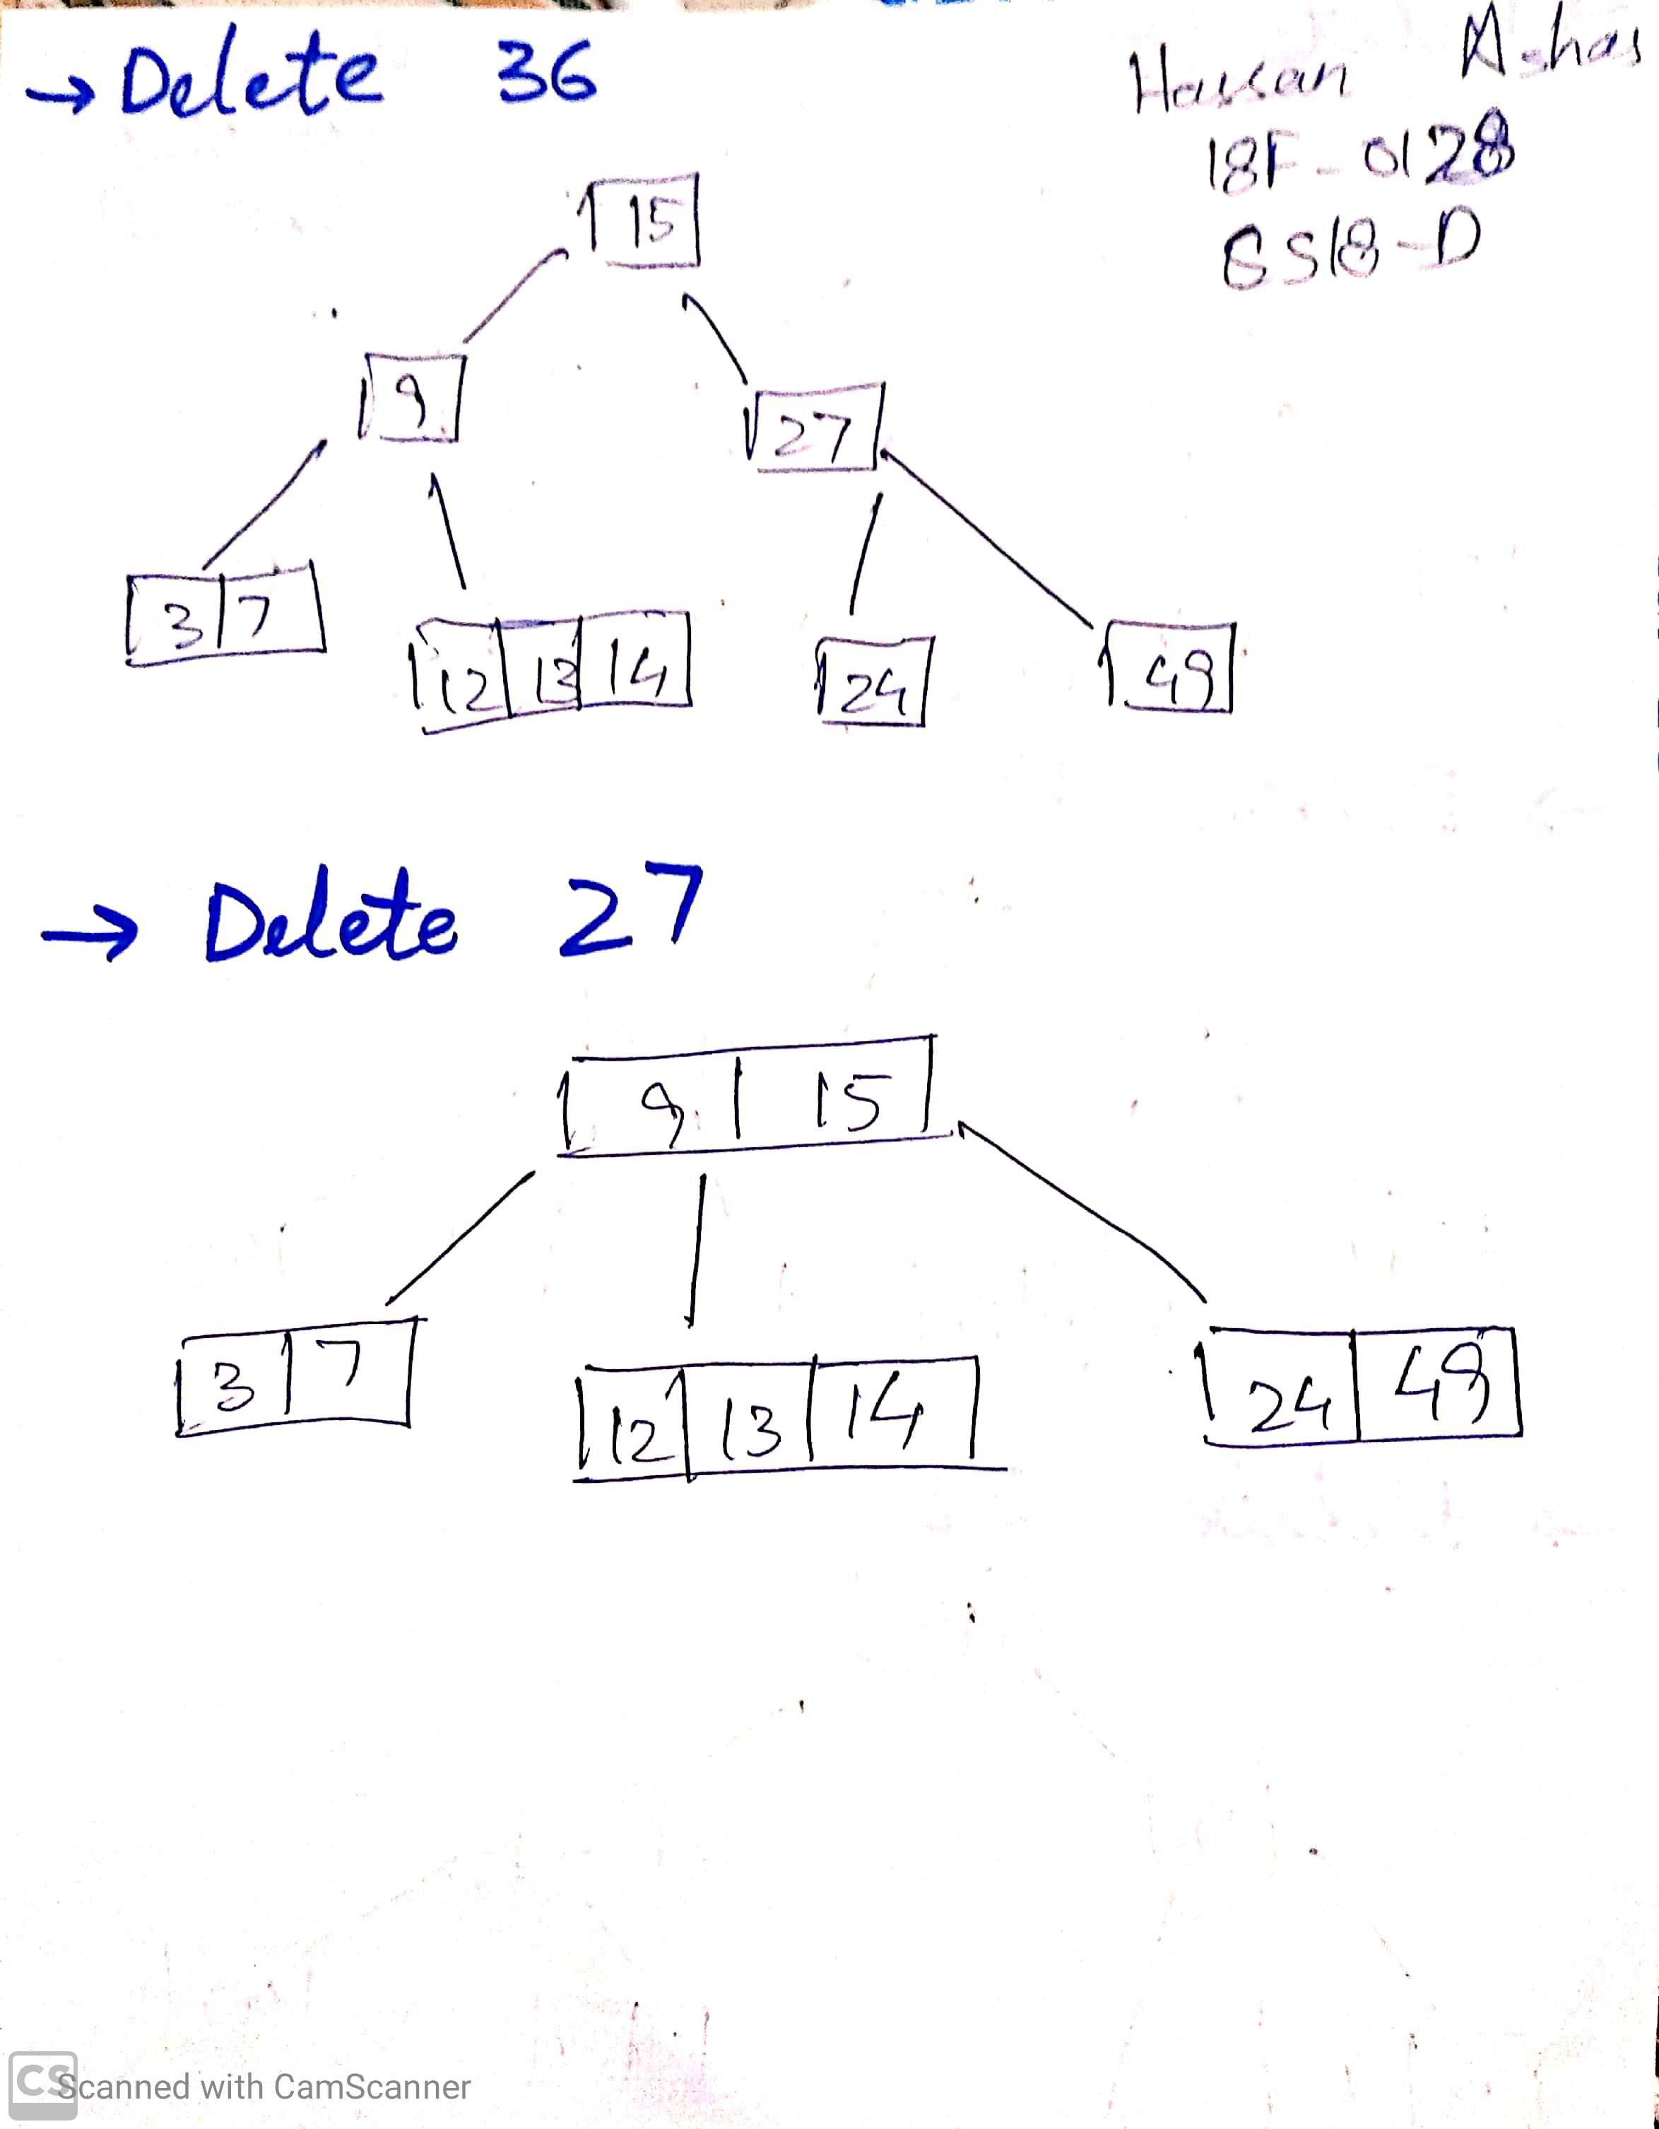

**Question 4: Solution: Upload Image of your work here**

